

**Tribhuvan University Faculty of Humanities and Social Science**

**A PROJECT REPORT ON**

**Second Hand Buying and Selling Goods**

**Submitted to**

**Department of Computer Application**

**Lumbini ICT Campus**

***In partial fulfillment of the requirements for the Bachelors in Computer Application***

Submitted By:

**Aakash Kandel**

TU Reg.no: 6-2-1194-48-2020

Under the Supervision of

**Er. Mod Nath Acharya**



**Tribhuvan university**

**Faculty of Humanities and science studies**

**Lumbini ICT campus**

**Supervisor’s recommendation**

The supervisor wholeheartedly endorses the project titled "Second-Hand Buying and Selling Goods," exclusively developed by **Aakash Kandel**, acknowledging its exceptional execution and successful fulfillment of the requirements for the degree of Bachelor of Computer Application. This project is highly recommended for final evaluation.

………………………….

**Er Mod Nath Acharya**

Signature of supervisor



**Tribhuvan University**

**Faculty of humanities and social studies**

**Lumbini ICT Campus**

**LETTER OF APPROVAL**

This document certifies that **Aakash Kandel's** project, "Second-Hand Buying and Selling Goods," has undergone a comprehensive evaluation to fulfill the requirements for the degree of Bachelor in Computer Application. In our expert opinion, this project demonstrates satisfactory scope and exceptional quality, meeting the standards expected for the degree.

|  |  |
| --- | --- |
| …………………….  Nischal Khatiwada  **Supervisor** | …………………….  Er. Mod Nath Acharya  **HOD/coordinator** |
| ……………….…..  **Internal Examiner** | ………………….…  **External Examiner** |

**ACKNOWLEDGEMENT**

I would like to extend my sincere gratitude to the authorities at Tribhuvan University for providing me with the invaluable opportunity to work on the project titled 'Buying and Selling Goods.' This project has offered me a platform to apply and explore the practical implications of the theoretical knowledge and expertise I have acquired during my academic journey.

I am deeply appreciative of the unwavering support and guidance extended to me by Lumbini ICT Campus throughout this endeavor. I wish to express my heartfelt thanks to my supervisor, **Er. Mod Nath Acharya**, whose scholarly mentorship and valuable suggestions have been instrumental in navigating the complexities of this research. Without his continuous encouragement and belief in the project, this undertaking would have been immensely challenging.

Undoubtedly, this project has not only allowed me to delve deeper into the subject matter but has also significantly enhanced my practical acumen and skills. I am indebted to my friends, family members, and teachers who generously shared their insights and perspectives, which have greatly contributed to the improvement and enrichment of this work.

Furthermore, I extend my deepest appreciation to all individuals who have directly or indirectly contributed to the successful completion of this project. Their guidance and encouragement have been a source of motivation throughout this journey.

With heartfelt thanks,

**Aakash Kandel**

**Abstract**

The overarching goal of the "Second Hand Buying and Selling Goods" project is to develop an exceptionally user-friendly and comprehensive online platform that enables individuals to effortlessly list and purchase pre-owned items using a single user ID. In an effort to cultivate a trustworthy and dependable trading environment, the project places a prime emphasis on transparency and accountability, eliminating the need for a traditional rating system. This approach promotes open and direct communication between users, ensuring that they can establish a sense of trust without relying on formalized ratings. To optimize the overall shopping experience, the project introduces an advanced search feature, empowering users to swiftly find and explore items that align with their specific preferences. This sophisticated functionality streamlines the process of item discovery, making it easier for buyers to find the desired products within the vast array of pre-owned offerings. Additionally, the project incorporates a cash-on-delivery option to enhance security during the purchase process. By providing this payment method, users can place their orders with added confidence, as payment is confirmed only upon successful delivery of the purchased item, ensuring a secure and reliable transaction. In conclusion, the "Second Hand Buying and Selling Goods" project is dedicated to delivering a seamless and user-centric experience. With its unwavering focus on a single user ID, transparent trading practices, efficient search capabilities, and secure payment options, the project endeavors to create an environment that fosters positivity, trust, and security for all participants in the dynamic realm of pre-owned goods trading.

Contents

CHAPTER 1: INTRODUCTION 1

1.1 Introduction 1

1.2 Problem statement 1

1.3 Objectives 1

1.4 Scope and limitation 2

1.5 Report organization 3

CHAPTER 2: BACKGROUND STUDY AND LITERATURE REVIEW 4

2.1 Background study 4

2.2 Literature Review 5

CHAPTER 3: SYSTEM ANALYSIS AND DESIGN 6

3.1 System Analysis 6

3.1.1 Requirement Analysis 7

3.1.2 Feasibility study: 9

3.1.3 E-R Diagram 11

3.1.4 DFD (data flow diagram) 12

3.2 System Design 14

3.2.1 Architectural Design 14

3.2.2 Database schema design: 15

3.2.3Interface Design 18

CHAPTER 4: IMPLEMENTATION AND TESTING 20

4.1 Implementation 20

4.1.1 Tools Used 21

4.2 Unit testing 22

4.2.1 Test Cases for Unit Testing 22

4.2.2 Test Cases for System Testing 23

CHAPTER5: CONCLUSION AND FUTURE RECOMMENDATION 28

5.1 lesson learned/outcome 28

5.2 Conclusion 28

5.3 Future recommendation 28

Reference 30

**List of Figure**

Figure 1:Waterfall Model 6

Figure 2: Use Case Diagram 8

Figure 3:Time Plan 11

Figure 4:Er Diagram 11

Figure 5:DFD level 0 12

Figure 6:DFD level 1 13

Figure 7:Architecture Diagram 14

Figure 8:Schema Design 15

Figure 9:Database Design 16

Figure 10:User Details Database table 16

Figure 11:Product Details Database table 17

Figure 12:Payment Details Database table 17

Figure 13:Order Details Database table 17

Figure 14:Admin Dashboard 30

Figure 15:User management 31

Figure 16:Add user form 31

Figure 17:product details 32

Figure 18:Order Details 32

Figure 19:Update user profile 33

Figure 20:Product Listing form 33

Figure 21:Order List details 34

Figure 22:User menu 34

Figure 23:Admin menu 35

Figure 24:Login form 35

Figure 25:Signup form 36

Figure 26:Email for forgot password 36

Figure 27:User support 37

Figure 28:Product details form 37

Figure 29:Delete or Cancel interface 38

Figure 30:Send message to product owner 38

Figure 31:Log Sheet 1 39

Figure 32:Log Sheet 2 40

**List of Table**

Table 1:Admin login Login test cases 23

Table 2:Add and view user test cases 24

Table 3:Add and view product test cases 25

Table 4:Register user test cases 26

Table 5:User Login test cases 27

# CHAPTER 1: INTRODUCTION

## 1.1 Introduction

Second hand buying and selling products is a web-based application that is designed to sell and buy goods or materials which have been used or even new products. This project aims to supply goods and materials for those who seek to buy desired products at a suitable and reasonable price. This system has many facilities where users can buy goods that are included in the system category. This system will provide a convenient and secure marketplace for individuals to connect and engage in transactions involved in used as well as new items.

## 1.2 Problem statement

The second-hand buying and selling market in Nepal face challenges due to the absence of a centralized platform, lack of trust and security, limited reach and visibility, informal transactions, inefficient search options, and limited promotion of sustainable practices. These challenges hinder the seamless exchange of used products and restrict the market's potential. Addressing these issues and providing a user-friendly platform that fosters trust, expands reach, streamlines transactions, improves search capabilities, and promotes sustainability will contribute to the growth and development of the second-hand market in Nepal.

## 1.3 Objectives

The objective of the proposed Online Second Hand Buying and Selling is that users can buy and sell goods in an efficient and systematic manner. This project aims to address the growth demand for a convenient and secure marketplace for individuals to engage in transactions involving used items.

With the proposed system, the achievable advantages are as follows:

● To provide easy and convenient transactions.

● To maintain trust and security.

● To promote sustainability and cost-effectiveness.

● To provide faster community engagement.

## **1.4 Scope and limita**tion

Scopes include:

**Platform Development:** The project aims to develop a user-friendly online platform for buying and selling goods in the second-hand market. The platform will include features like item listings, search functionalities, user profiles, secure payment gateways, and automated notifications.

**Multiple Categories:** The platform will cater to various categories of goods, such as electronics, clothing, furniture, books, and more, to accommodate a diverse range of user preferences and needs.

**User Authentication:** The system will implement a robust user authentication mechanism to ensure the security and privacy of user data, allowing only registered and verified users to participate in transactions.

these online Second hand buying and selling goods systems have few limitations. Some of the limitations of this system are:

**Geographical Constraints:** The project's scope may be limited to specific regions or countries initially, depending on the platform's target audience and legal considerations.

**Limited Sellers:** In the early stages, the number of sellers and listings on the platform may be limited, affecting the variety and availability of goods for buyers.

**Payment Integration:** Integrating secure payment gateways can be challenging and subject to external factors such as financial regulations and third-party service availability.

**Security Concerns:** Despite robust user authentication, the platform may face security vulnerabilities and threats, requiring constant monitoring and updates to ensure data protection.

**User Adoption:** The success of the project depends on user adoption and engagement. Convincing users to switch from traditional methods to the new platform may present challenges.

**Competition:** The project may face competition from established second-hand buying and selling platforms, impacting its market penetration and growth.

**Technical Constraints:** The project's scope may be limited by technical constraints such as budget, time, and resources available for development and maintenance.

Overall, the project aims to create a viable and user-friendly platform for buying and selling goods in the second-hand market, but its success will depend on addressing these limitations and continuously adapting to meet user demands and market conditions.

## 1.5 Report organization

Chapter1: Topic “Introduction” contains the introduction to the project. It explains the project's objectives, scope, and limitations, as well as provides a brief description and summary. It also explains why we're working on this project.

Chapter 2- Topic “Background Study and Literature Review” present a critical evaluation of the context of our system-critical analysis of existing literature. It includes a description of our perspective of the previous system, as well as what our project wants to accomplish, as well as a comparison of the traditional and our planned system, the Online Food Ordering System.

Chapter 3-Topic “System Analysis and Design” includes a data flow diagram, modules, architecture as well as contains the requirement of the system its hardware requirement, and the software required to run our system. It also relates to shaping organizations, improving performance, and achieving objectives for profitability and growth.

Chapter 4-Topic “Implementation and Testing” includes the process of testing implementations of technical specifications. It consists of all the ways how the functions are implemented and what functions are used to implement them.

Chapter 5-Topic “Conclusion and Future Recommendations” includes how well have we achieved our original aim and objectives, what were the limitations and scopes of our system, what should we do differently next time, consequences for research funding and practice.

# CHAPTER 2: BACKGROUND STUDY AND LITERATURE REVIEW

## 2.1 Background study

As part of the background study for the "Second Hand Buying and Selling Goods" project, I conducted thorough research and analysis to understand the market demand and potential challenges in the second-hand goods trading industry. Through extensive online research, surveys, and interviews with potential users and stakeholders, I gathered valuable insights into their preferences, pain points, and expectations from an online platform dedicated to buying and selling pre-owned items. I explored existing online marketplaces and e-commerce platforms to identify gaps and limitations specific to the second-hand goods niche. I closely examined their features, user interfaces, payment methods, and security measures to understand what works well and where improvements could be made. During the research process, I discovered a growing demand for a user-friendly and reliable platform that caters exclusively to second-hand goods. Users expressed a strong interest in a platform that prioritizes transparency, trustworthiness, and data security, enabling seamless and secure transactions. Based on the study's findings, it became evident that certain aspects needed special attention, such as user-friendliness, extended service hours, order confirmation, and product ratings. I recognized the importance of addressing these pain points to create a positive and engaging user experience. Additionally, I explored the emerging trends in the sharing economy and sustainability movements, recognizing the potential of the second-hand market to contribute to a more environmentally conscious society. This further motivated the project's mission to encourage sustainable consumption practices and support the growth of the second-hand market. By incorporating the knowledge gained from the background study, the "Second Hand Buying and Selling Goods" project is designed to offer a solution that aligns with users' needs and expectations. The platform aims to provide a modern and efficient experience, where individuals can seamlessly list and purchase pre-owned items, fostering a sense of trust and community within the second-hand goods trading ecosystem. Throughout the study, I emphasized the importance of data security and user privacy, ensuring that the platform's infrastructure would meet the highest standards in safeguarding sensitive information. Overall, the background study played a vital role in shaping the project's vision and guiding its development process, ensuring that it caters to the real needs and aspirations of users in the second-hand goods market.

## 2.2 Literature Review

The literature review for the "Second-Hand Buying and Selling Goods" project thoroughly examines the existing body of research related to e-commerce platforms, online marketplaces, and user behavior in the context of buying and selling second-hand goods. It delves into the growth and significance of e-commerce platforms, with a specific focus on their impact on the convenience and accessibility of the second-hand market. By analyzing previous studies, the review aims to gain insights into consumer preferences, behaviors, and decision-making processes when engaging in second-hand transactions. Understanding user behavior is a crucial aspect of the review, as it helps identify key factors that influence buying and selling decisions in the second-hand market. Factors such as price sensitivity, product condition, and the level of trust users place in the platform can significantly impact their engagement and satisfaction. Therefore, this understanding will guide the design of the project's user interface, ensuring it is user-friendly, intuitive, and capable of meeting user expectations. The review also places a strong emphasis on security and trust-building measures. It investigates existing strategies used by successful online marketplaces to prevent fraud, protect user data, and foster trust between buyers and sellers. By incorporating such measures into the project, it aims to create a secure and reliable environment for transactions, thereby enhancing user confidence in the platform. In addition to drawing from existing research, the literature review includes an analysis of case studies of successful online marketplaces in the second-hand market. By studying their best practices and success factors, the project gains valuable insights that can inform its implementation, improving the chances of success and user satisfaction.

Overall, the literature review serves as a comprehensive foundation for the "Second-Hand Buying and Selling Goods" project. It provides valuable knowledge and insights that guide the development of a user-centric, secure, and successful online platform for buying and selling second-hand goods. By incorporating relevant findings and best practices, the project can offer an efficient and satisfying experience to users, fostering a thriving and reliable marketplace for second-hand transactions.

# CHAPTER 3: SYSTEM ANALYSIS AND DESIGN

## 3.1 System Analysis

System analysis is the process of collecting facts, identifying the problems, and decomposition of a system into its components. System analysis is conducted for the purpose of studying a system or its parts in order to identify its objectives. It is the problem-solving technique that improves the system and ensures that all the components of the system work efficiently to accomplish their purpose. Second Hand buying and selling goods would be initiated using a waterfall model and different phases are used for the completion of works.

I.e., waterfall model is a popular model of the software development lifecycle to make a successful project. The waterfall model describes a development method that is linear or sequential. The whole process of system development is divided into separate phases like requirement analysis, design, implementation, testing, deployment, and maintenance. Once the one phase is completed the development process to the next phase starts and this is no turning back. Moreover, a waterfall model is suggested for the project because it has clear objectives and solutions. I take the waterfall model for the online food ordering system project mainly because the waterfall model is simple, easy to use, and manage, waterfall model works well for smaller the and project will be completed in a short period of time with a low budget where requirements are very well understood and the main advantage are processed and results are well documented.

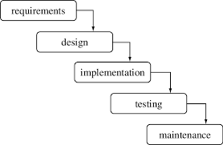

**Figure 1:Waterfall Model**

### 3.1.1 Requirement Analysis

Requirement analysis also called requirements engineering, allows software engineers to define user needs early in the development process. It helps them deliver a system that meets customer time, budget, and quality expectations. In this article, we review the requirements analysis process and explain various analysis techniques. The goal of this phase is to decompose analyze and detail the requirement across the system design. The following section presents the complete set of functional and non-functional requirements identified for the second hand buying and selling system. In prioritizing functional requirements for the entire system, the user roles of buyers and sellers take precedence, followed by the administration functionalities. Non-functional requirements, on the other hand, center around the system's operation and encompass aspects such as security, stability, reliability, and performance, all of which are vital for ensuring a professional and seamless user experience.

1. **Functional Requirements:**

Functional requirements define the capabilities and functions that a system must be able to perform successfully. Functional requirements are those requirements in the system that are used to illustrate the internal working nature of the system, and explanation of each subsystem. It consists of what task the system should perform, technical information, various processes, and other functionality. The specified functional requirements for the second hand buying and selling goods System are presented in this section. Use case diagrams are used to describe the functional requirements as they represent the system’s functions at the most basic level. The functional requirements are:

There is main two users who operate the system.

* Admin (Service Provider)
* Users: all who use Online buying and selling goods.

**Admin Functionalities**

The system should let the administrator.

* Dashboard
* User management
* Product management
* Order Details
* Logout

**User Functionalities**

* Homepage
* Login to the website
* User homepage
* Buy/sell goods
* To update his/her profile.
* Product listing
* Product Details
* Payment Confirmation
* 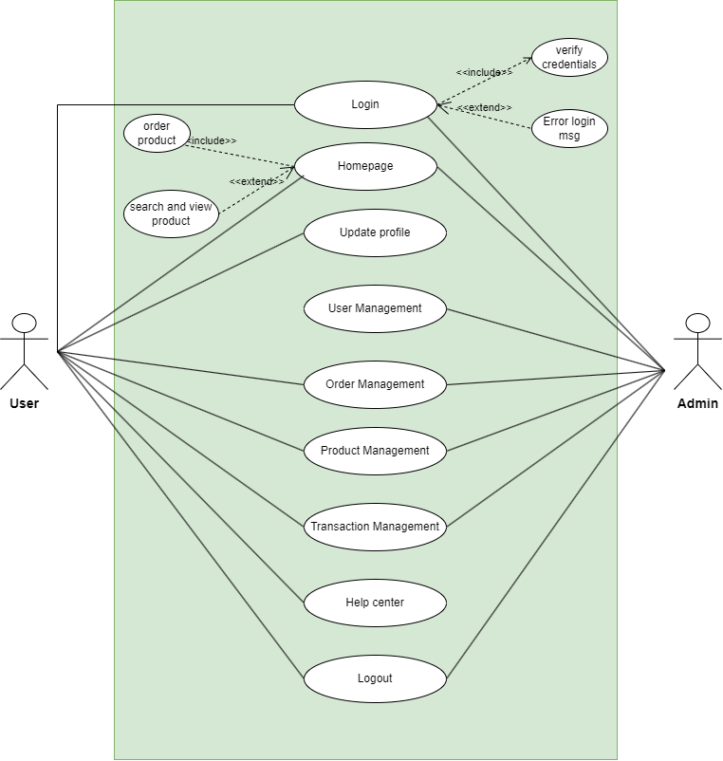 Help Center

**Second Hand buying and selling system**

**Figure 2: Use Case Diagram**

1. **Non-functional requirement**

The non-functional requirement describes constrains for implementing the project. Some of them are: the central sever has to be provided at secured area, the system must be maintainable and expandable, and the network infrastructure has to be private network client machines at each of the user side must be installed. In each of the each of user there should be technically supporting people. The user should have also basic computer skills and training should be provided to the employee on the demo version of the management application. The following non-functional requirements are included in the system:

* Secure:The application is secured for every kind of its users because here is the facility of session management and password encryption. If any user logout from any session, then nobody will be able to access his/her profile without knowing confidential password.
* Reliable: The system should be reliable, for handling the occurrence of errors.
* Usability: The users should able to understand the menu and options providing by the system. The system shall provide an easy-to-use interface so that the users do not strain to interact with the system.
* Performance: The system should respond fast, mostly depends the connection of speed and the processor of user device.
* Accessibility and Availability: The system should be up and running whenever needed.

### 3.1.2 Feasibility study:

A feasibility study is the initial design stage of any project, which brings together the elements of knowledge that indicate if a project is possible or not. A feasibility study was conducted for the project with the goal to see if a system idea is feasible. So far, during the development of the project Online Food Ordering System, we have four major categories of the feasibility study.

* **Operational feasibility:**

As our project plan satisfies the requirement identified in the requirement analysis phase of system development. Our application is operationally feasible because it is simple and needs only a general idea to operate it is not necessary to have a well-trained expert. Our system has a user-friendly interface that makes it simple for users to utilize.

* **Economical feasibility:**

As our system utilizes free software such as HTML, CSS, JS, and MYSQL, which will not generate any costs also the application does not spend much more money so our system is economically feasible. But because our project is a college project so we do not need to check whether our project is economically feasible or not.

* **Schedule feasibility:**

Schedule feasibility is the most important for the success of a project after all it analyzed time it will take to complete a project which has a great impact on the organization as the purpose of the project may fail if it can’t be completed on time. As our project is short, the requirement for the system is already fixed and it cannot be changed, we manage a perfect time period for our project by analyzing and discussing with experts, so we summarize that our system is schedule feasible.

* **Technical feasibility:**

For to develop the system we include the correct required resources and technologies such as HTML, CSS, PHP, and MySQL as the server are the main technologies and tools used in our system which are freely available, and the system developer has lots of technical experience. We will conduct systematic information-sharing training with an associated user guide.so, our project is technically feasible.

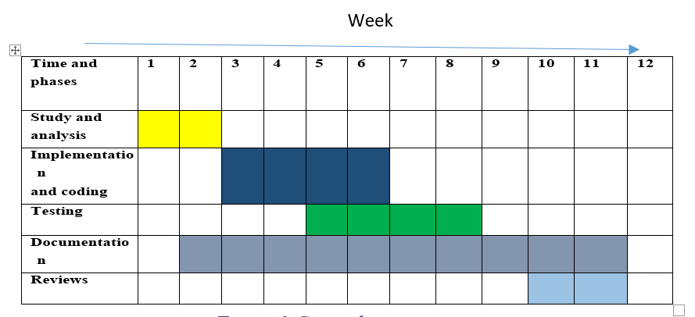

**Figure 3:Time Plan**

### 3.1.3 E-R Diagram

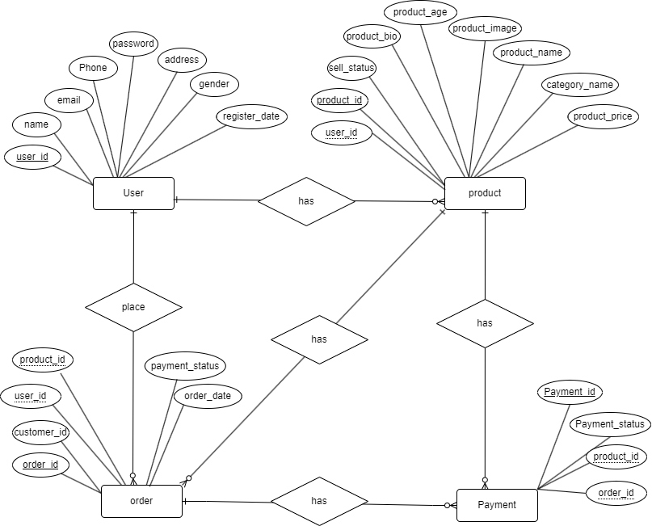

**Figure 4:Er Diagram**

### 3.1.4 DFD (data flow diagram)

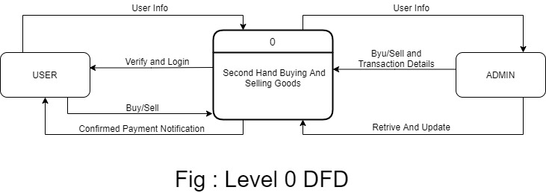

**Figure 5:DFD level 0**

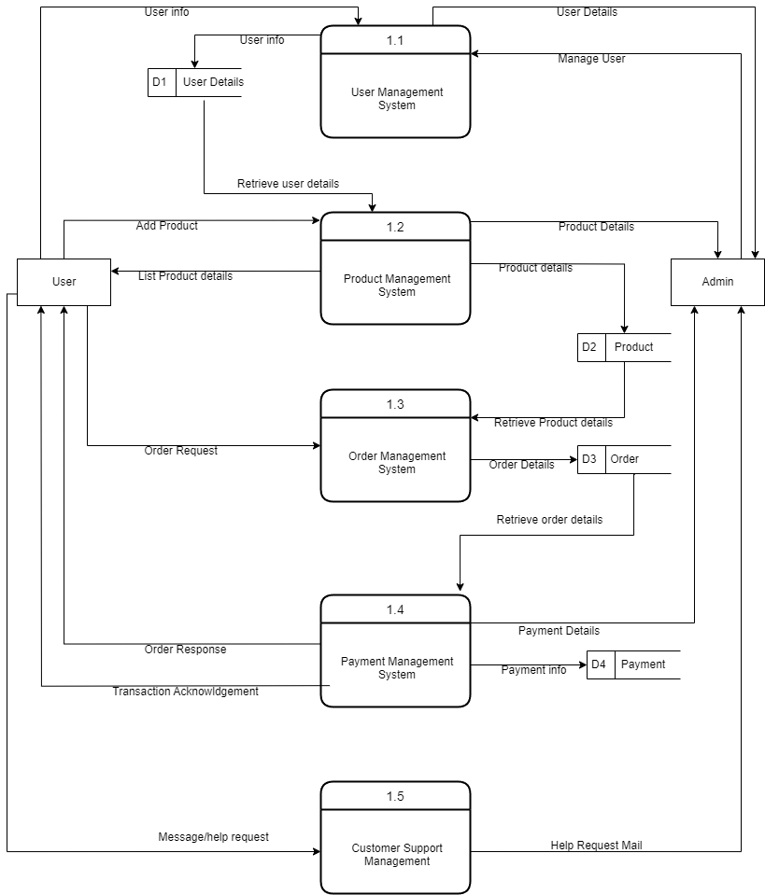

**Figure 6:DFD level 1**

## 3.2 System Design

System design is the process of defining elements of a system like modules, architecture, component, and their interfaces and data for a system based on the specified requirements. System design is the process of defining, developing, and designing systems that satisfy the specific needs and requirements of an organization.

### 3.2.1 Architectural Design

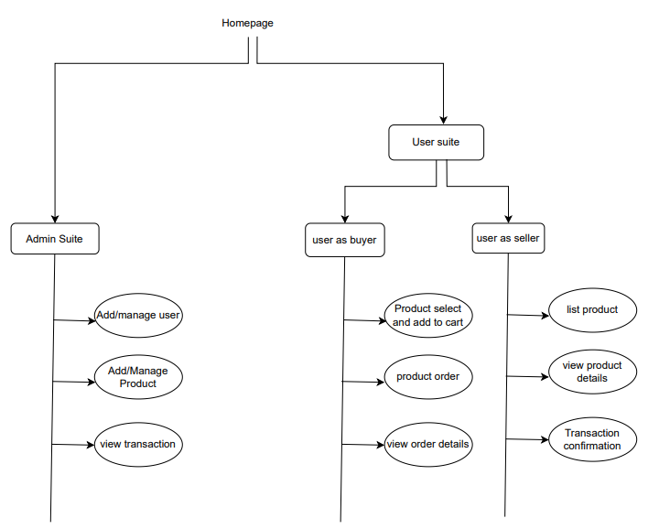An architectural diagram for a software project is a visual representation of the system's overall structure and how its components interact with each other. In the case of online tutor project, the architectural diagram provides a high-level overview of the system and its various components, including the user interface, database, application server, and external systems or services. 18 The diagram helps to illustrate how these components fit together and how data flows through the system. It can also help to identify potential bottlenecks or areas of the system that may require optimization

**Figure 7:Architecture Diagram**

### 3.2.2 Database schema design:

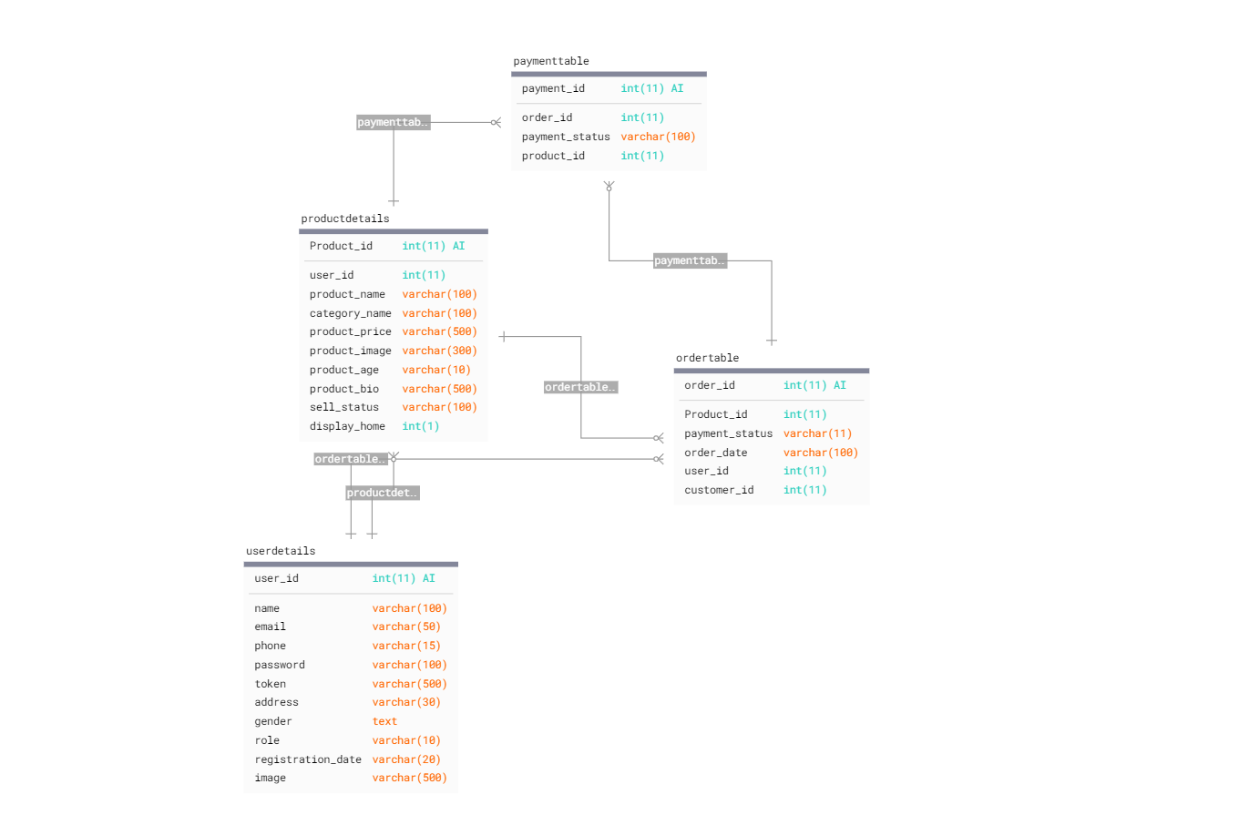

**Figure 8:Schema Design**

#### 3.2.2.1 Database design

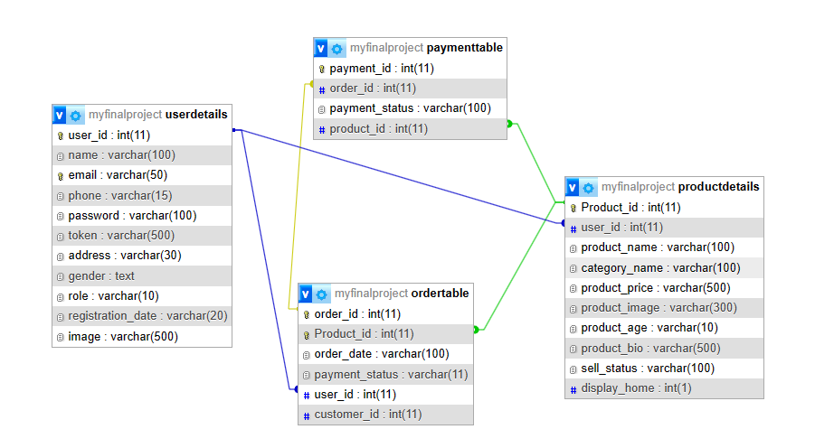

**Figure 9:Database Design**

#### 3.2.2.2 Data Dictionary

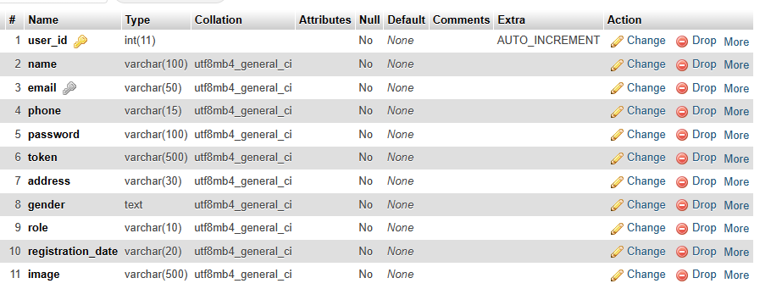

**Figure 10:User Details Database table**

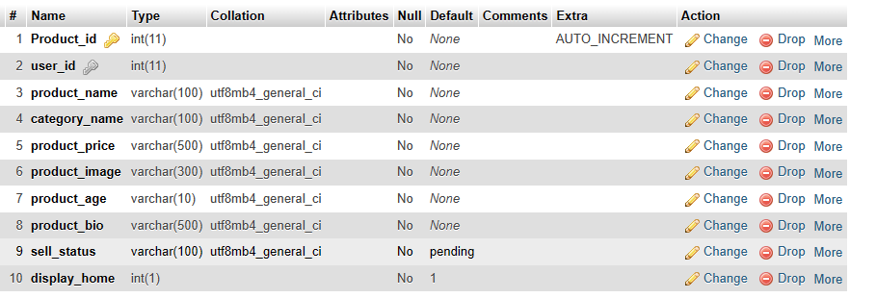

**Figure 11:Product Details Database table**

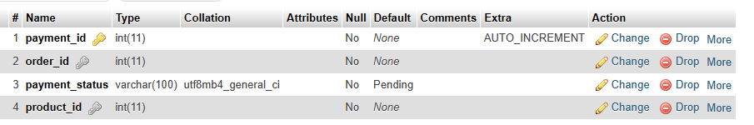

**Figure 12:Payment Details Database table**

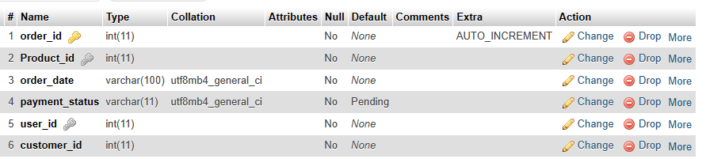

**Figure 13:Order Details Database table**

### 3.2.3Interface Design

Designing the interface for a second-hand buying and selling platform involves creating user-friendly and intuitive screens for both buyers and sellers, as well as an admin panel for overseeing the platform's operations. Here's a breakdown of the interface design:

1. **Homepage**

**Header:** Contains the platform's logo, navigation menu, and user login/register options.

**Search Engine:** Prominently displayed at the top, allowing users to search for products by keywords, categories, and other filters (e.g., price range, location).

**Product Listings**: Display a grid of product cards, each showing a product's image, title, price, and location. Users can scroll through these listings.

**Filters:** On the side or above the product listings, offer filter options (e.g., category, condition, price range) to refine search results.

1. **User profile**

**User Dashboard:** After login, users are directed to their dashboard, which includes options for viewing listed items, account settings, and transaction history.

**Listed Items:** Display a list of items the user has listed for sale. Include options to edit, remove, or mark items as sold.

**Payment Confirmation:** A section where users can confirm or reject payments for sold items.

1. **Product Listing**

In the menu bar, provide an option for users to list their items. This form should allow users to upload images, provide product details (title, description, price, category, condition), and set contact preferences.

1. **Selling Flow**

When a user clicks on a buy button, a detailed page opens, displaying images, title, description, price, contact information of the seller, and a button to request confirmation.

1. **Admin Panel**

**User Management:** Admin can add or remove users, manage their profiles, and respond to user requests for assistance.

**Product Management:** Admin can add, remove, or edit product listings. Also, handle requests to remove or address damaged products.

**Order Details:** Display a comprehensive view of all transactions, including order status, payment status, and communication logs between buyers and sellers.

1. **Product Confirmation**

When a user clicks the "Done" after know the details of the product, the product owner receives a notification and can accept or reject the request.

1. **Payment Flow**

Cash and delivery method is implemented in the system

1. **Notification**

Notify users about product status changes, new messages, or important updates through mail

1. **Help and Support**

Include a section for users to contact customer support

# CHAPTER 4: IMPLEMENTATION AND TESTING

## 4.1 Implementation

In this chapter, we focus on turning the technical specifications of the Second-Hand Buying and Selling System into a practical reality. We explore the various phases of development, including frontend and backend implementation, database integration, and technology selection.

System Development Phases

The implementation process comprises four key stages. Firstly, we refine the system's requirements to ensure clarity and coherence. Next, we carefully select suitable technologies and tools. Thirdly, we develop the frontend for an intuitive user interface and the backend for data processing. Finally, we design and integrate a robust database.

System Enhancements

Several enhancements refine the system's functionality. User management features secure authentication and profile management. Admin functionalities enable effective system administration. The product listing and search functions offer a smooth user experience. A secure payment gateway facilitates safe transactions, and reporting and analytics provide valuable insights.

Operational Guidelines

This section provides instructions for operating the system effectively. Users are guided through registration, product listing, purchasing, and dispute resolution. Administrators receive best practices for efficient system management and handling user concerns.

In conclusion, the implementation phase of the Second-Hand Buying and Selling System transforms technical specifications into a fully functional platform. With meticulous planning and development, the system empowers users with a seamless experience, ensuring secure transactions and enhanced functionalities.

### 4.1.1 Tools Used

We use different tools and techniques for the development of the system. We use HTML, CSS, and JAVASCRIPT for the frontend and PHP for the backend development. We use SQL for managing databases.

**Html and CSS:**

HTML (HyperText Markup Language) was used to structure the content and layout of the web pages. I employed HTML to define the various elements such as headings, paragraphs, lists, tables, forms, and buttons, which are essential components of the user interface.

CSS (Cascading Style Sheets) was employed to control the presentation and styling of the HTML elements. With CSS, I could specify the font styles, colors, spacing, positioning, and other visual aspects of the interface. By separating the content from the presentation, CSS allowed me to maintain consistency and easily update the design across multiple pages.

**JavaScript:** JS is used to add events and triggers to the website. The website also uses JS to acquire the system time for date and time reasons.

**PHP with MySQL:** PHP is a server-side scripting language that allows you to connect to a database, as CRUD actions such as editing, deleting, and searching news is required, PHP is utilized in association with the MySQL database, which stores database tables.

**XAMPP Server:** XAMPP is a popular cross-platform web server that allows programmers to design and test their code on a local webserver. It is used in project development to host the portal locally and centralize the database.

**Visual studio code:** visual studio code is a source code editor its features include support for debugging, code refactoring, etc. Users can change the theme keyboard shortcuts, and install extensions that add additional functionality.

4.1.2 Implementation Details of Modules

Following are all the modules designed for the Second-Hand Buying and Selling System:

**Admin Module**

The Second-Hand Buying and Selling System is equipped with a robust admin module that empowers authorized administrators to efficiently manage various aspects of the platform. With secure login credentials, the admin gains access to a comprehensive set of tools for user and product management, as well as access to essential lists like the user list, product list, and payment list.

**User Module**

The User Model within the Second-Hand Buying and Selling System enables users to list their products for sale and buy items from other users directly within the model. After placing an order for a product, the goods owner is notified and can respond by confirming the payment, validating the purchase request.

## 4.2 Unit testing

The overall aim for testing a system is to ensure that the system meets its entire functional requirement and to check its performance. The accuracy of the program can be tested with some varying data, testing gives assurance that the new system will achieve its objectives and purpose. Testing is basically an attempt of executing program to find bugs. It consists of various types for which a system is subjected to but the ones to be carried out are the testing objectives. The test plan presents the test in details through identifying the test case areas within the system.

### 4.2.1 Test Cases for Unit Testing

Unit testing is a critical software testing approach used to evaluate individual units or components of Second-Hand Buying and Selling System. The primary purpose is to validate the proper functioning of each unit in the system. Developers conduct unit testing during the application's development phase to ensure its accuracy and reliability. Second-Hand Buying and Selling System was divided into specific components, such as the admin component and user (as a buyer and seller) component. Each component was thoroughly tested in isolation. Throughout the testing process, various input values and scenarios were examined to verify the corresponding outputs. The goal was to ensure that all components work effectively and deliver the expected results. By implementing comprehensive unit testing, the developers were able to identify and rectify any issues or errors, enhancing the overall reliability and performance of the Second-Hand Buying and Selling System.

### 4.2.2 Test Cases for System Testing

System testing is a level of testing that validates the complete and fully integrated software product. In software testing the behavior of whole system is tested as defined by the scope of the developed project. It is the most of the final test top verify that the system to be delivered meets the specification and purpose. System testing should focus on testing interactions between the components and objects that make up a system as well as test the reusable components or system to check that they work as expected when they integrated with new component.

**Table 1:Admin login Login test cases**

|  |  |  |  |  |  |  |
| --- | --- | --- | --- | --- | --- | --- |
| **Test Case** | **Test Scenario** | **Test Steps** | **Test Data** | **Expected Results** | **Actual**  **Result** | **Pass/**  **Fail** |
| TC01 | Check the login module with correct input access the system | 1. Go to site http://localhost/myfinalproject/login.php  2.Enter username  3.Enter password  4.Click login | Email=Akadmin@gmail.comPassword=000 | Allow the admin login to the system. | The admin logged into the system. | Pass |
| TC02 | Check the login module with incorrect input access the system | 1.Go to site http://localhost/myfinalproject/login.php  2.Enter username  3.Enter password  4.Click login | Email=admin  Password=admin | Deny the admin access to the system | The admin was unable to login into the system. Error message incorrect username or password. | Pass |

**Table 2:Add and view user test cases**

|  |  |  |  |  |  |  |
| --- | --- | --- | --- | --- | --- | --- |
| **Test Case** | **Test Scenario** | **Test Steps** | **Test Data** | **Expected Results** | **Actual**  **Result** | **Pass/**  **Fail** |
| TC03 | This test Add user with correct input | 1. Go to site <http://localhost/myfinalproject/addusermanage.php> 2. EnterUser ID,Name, Email, Address, Phone,Gender,Password 3. Click submit | Driver ID: 350  Name: Aakash  Gender:male  Phone:9805449777  Email: Ak100@gmail.com  Address:Devchuli-1  Password: Ak@00000 | Allow the admin to save User. | The admin saved the new User. | Pass |
| TC04 | This test Add user with incorrect input | 1. Go to site   <http://localhost/myfinalproject/addusermanage.php>   1. Enter Driver ID, Name, Email, Address, Phone,Gender,Password 2. Click submit | Driver ID: 350  Name: Aakash  Gender:male  Phone:9805449777  Email: Ak100@gmail.com  Address:Devchuli-1  Password: Ak@00000 | Prompt an error “user already exists.” | The admin doesn’t add User. | Pass |

**Table 3:Add and view product test cases**

|  |  |  |  |  |  |  |
| --- | --- | --- | --- | --- | --- | --- |
| **Test Case** | **Test Scenario** | **Test Steps** | **Test Data** | **Expected Results** | **Actual**  **Result** | **Pass/**  **Fail** |
| TC05 | This test Add Product with correct input | 1. Go to site <http://localhost/myfinalproject/addproductmanage.php> 2. Enter UserID, Name,Category,Price,Imagefile, Age, bio 3. Click Save | User ID: 350  Name: TV  Category: Electronic  Price:50,000  Imagefile:///C:/Users/Aakas/Downloads/tvimage.png  Age:2years  Bio:Rowa tv for sale | Allow the admin to save product. | The admin saved the new product. | Pass |
| TC06 | This test Add Product with incorrect input | 1. Go to site <http://localhost/myfinalproject/addproductmanage.php> 2. Enter User ID,Name,Category,Price,Imagefile, Age, bio 3. Click Save | User ID: 350  Name: TV  Category: Electronic  Price:50,000  Imagefile:///C:/Users/Aakas/Downloads/tvimage.png  Age:2years  Bio:Rowa tv for sale | Prompt an error “User Doesnotexits”. | The admin doesn’t add Product. | Pass |

|  |  |  |  |  |  |  |
| --- | --- | --- | --- | --- | --- | --- |
| **Test Case** | **Test Scenario** | **Test Steps** | **Test Data** | **Expected Results** | **Actual**  **Result** | **Pass/**  **Fail** |
| TC07 | This test Register user with correct input | 1. Go to site http://localhost/myfinalproject/userhomepage/homepage.php and click signup 2. Enter User ID, Name, Email, Address, Phone,Gender,Password,image 3. Click submit | Name: Aakash  Gender:male  Phone:9805449777  Email: Ak100@gmail.com  Address:Devchuli-1  Password: Ak@00000  Image:img.jpeg (1200×960) | The User able to signup and redirected to login page. | The admin saved the new User. | Pass |
| TC08 | This test Register user with incorrect input | 1. Go to site http://localhost/myfinalproject/userhomepage/homepage.php and click signup 2. Enter User ID, Name, Email, Address, Phone,Gender,Password,image 3. Click Signup | Name: Aakash  Gender:male  Phone:9805449777  Email: Ak100@gmail.com  Address:Devchuli-1  Password: (empty)  Image:img.jpeg (1200×960) | Deny the user to register. Prompt an error “Please fill out this field”. | The user unable to register into the system. | Pass |

**Table 4:Register user test cases**

**Table 5:User Login test cases**

|  |  |  |  |  |  |  |
| --- | --- | --- | --- | --- | --- | --- |
| **Test Case** | **Test Scenario** | **Test Steps** | **Test Date** | **Expected Results** | **Actual**  **Result** | **Pass/**  **Fail** |
| TC09 | Check the login module with correct input access the system | 1. Go to site http://localhost/myfinalproject/login.php  2.Enter password  3.Click login | Email=Aakashkandel9777@gmail.com  Password=Aakash@123 | Allow the user login to the system. | The User logged into the system. | Pass |
| TC10 | Check the login module with incorrect input access the system | 1. Go to site http://localhost/myfinalproject/login.php  2.Enter password  3.Click login | Email=Aakashkandel@gmail.com  Password=Aakash | Deny the User access to the system | The was User unable to login into the system. Error message incorrect user not found or invalid password. | Pass |

# CHAPTER5: CONCLUSION AND FUTURE RECOMMENDATION

## 5.1 lesson learned/outcome

This project assisted me gain a practical experience and apply the knowledge assimilated from the previously course undertook. Putting the knowledge gained earlier and applying different techniques from past course was interesting and certain concepts, tools and technique only made sense after seeing their application in a real word scenario. It was extremely challenging at times but it has been great and worthwhile learning experience. This application is several users friendly and simple codes that have been adopted as well as prove to be a powerful software package in satisfy all requirement of the user.

The website I made by using the simple code in JavaScript, HTML, CSS and PHP with MySQL database which is thoroughly tested and implemented. The implementation of this system will reduce the paper work, time.

## 5.2 Conclusion

In conclusion, the second-hand buying and selling goods project has demonstrated significant potential and value for both consumers and the environment. Throughout the project, it became evident that the marketplace effectively facilitated the exchange of pre-owned items, encouraging a more sustainable and resource-efficient lifestyle. By giving used products a second life, the project contributed to reducing waste and conserving natural resources. The positive impact on the environment was clear, as the platform helped lower manufacturing emissions and the depletion of raw materials by reducing the demand for new products. Additionally, buyers benefited from more affordable options, enabling them to save money while still acquiring high-quality goods. Overall, the project showed promise in fostering a sense of community and promoting the spirit of recycling, sharing, and supporting one another.

## 5.3 Future recommendation

In addition to the unfinished requirements, there are other possibilities for further improving the project. This improvement may include:

* Delivery option: add a delivery option
* Payment options: add different payment options such as cash payment, eSewa, etc. allowing to save payment details for future use.
* Restaurant locator; allow to find and choose a nearby restaurant.
* Tracking on delivery

# Reference

|  |
| --- |
| Portal, "Mero Second Hand," [Online]. Available: https://www.merosecondhand.com [Accessed 02 May 2023]. |
| Commercial Website, "Hamro Bazar," [Online]. Available: https://hamrobazaar.com [Accessed 3 May 2023]. |
| Portal, "IMPLEMENTATION AND TESTING," 2020. [Online]. Available: https://portal.bazeuniversity.edu.ng/student/assets/thesis/. [Accessed 15 May 2023]. |
| guru99, "Unit Testing," 2021. [Online]. Available: https://www.guru99.com/unit-testing-guide.html [Accessed 16 May 2023]. |

**Appendices**

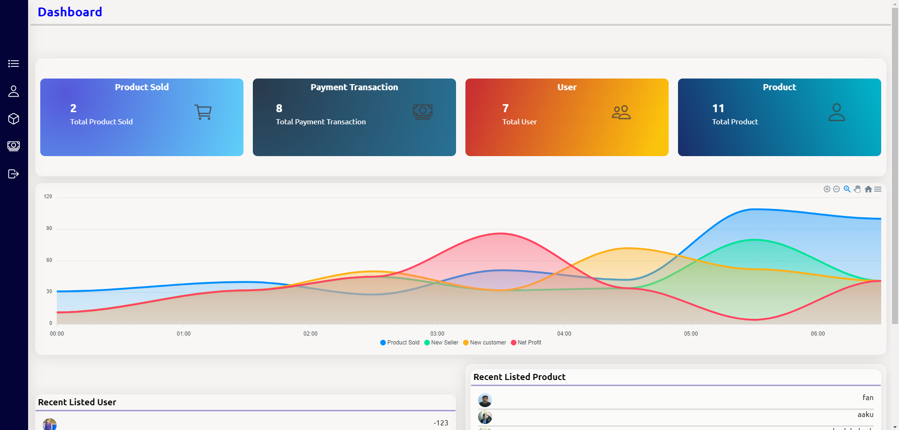

**Figure 14:Admin Dashboard**

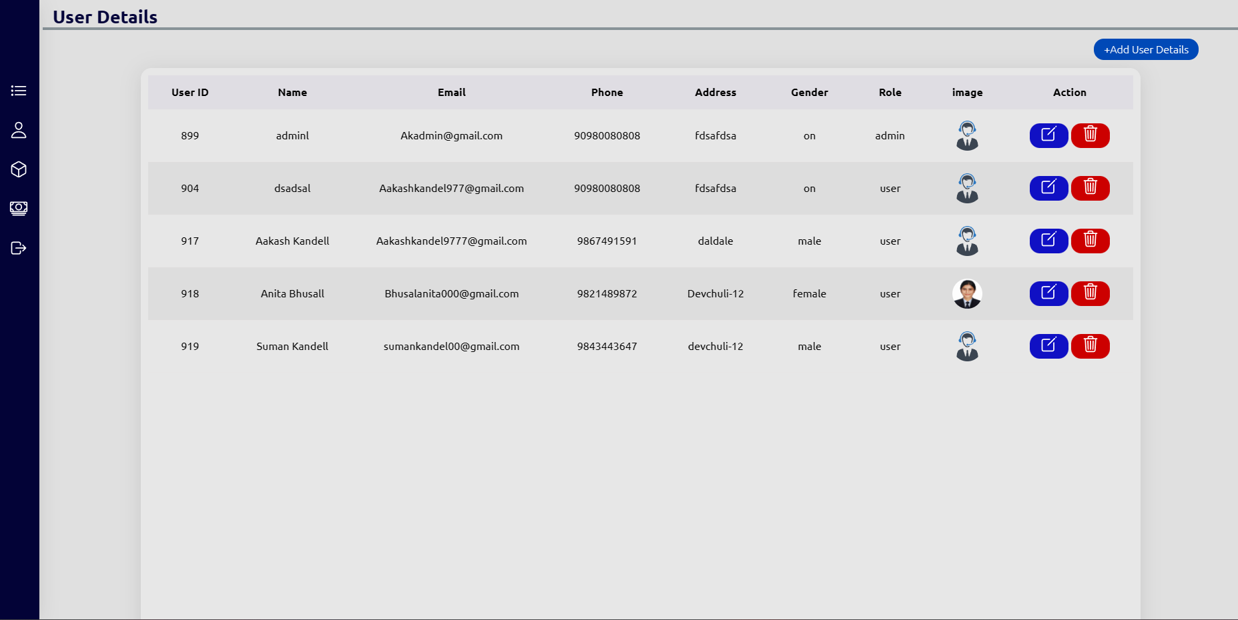

**Figure 15:User management**

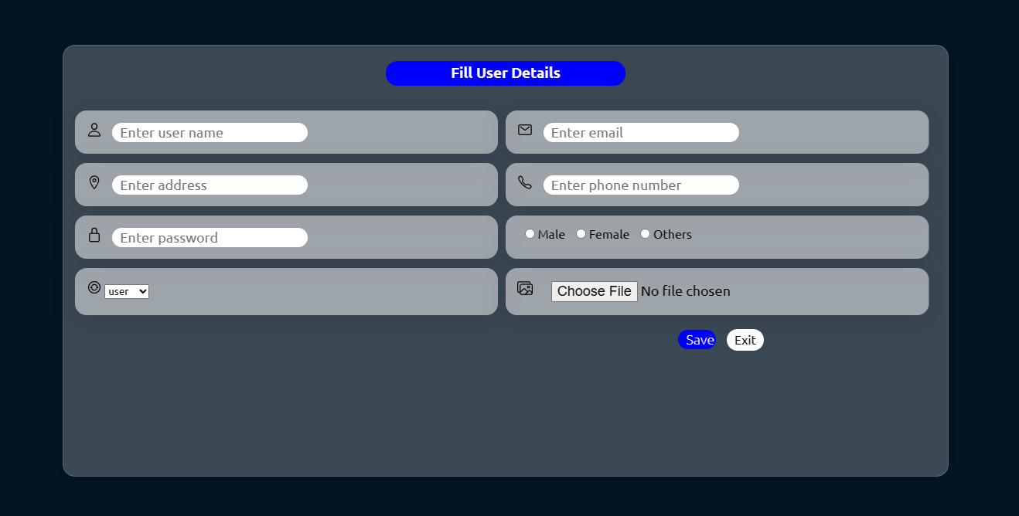

**Figure 16:Add user form**

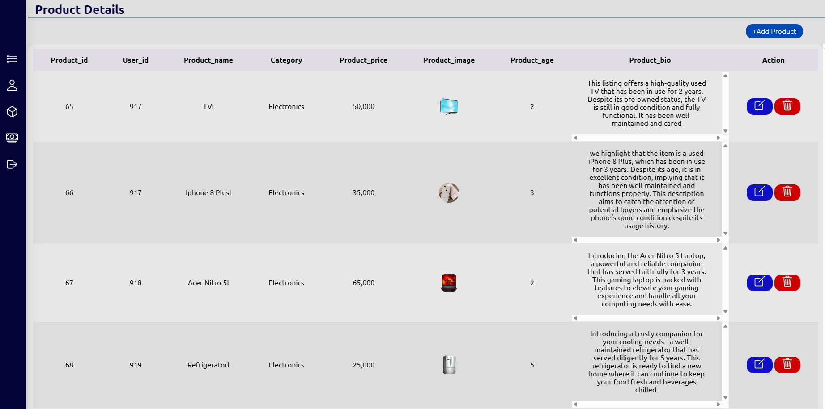

**Figure 17:product details**

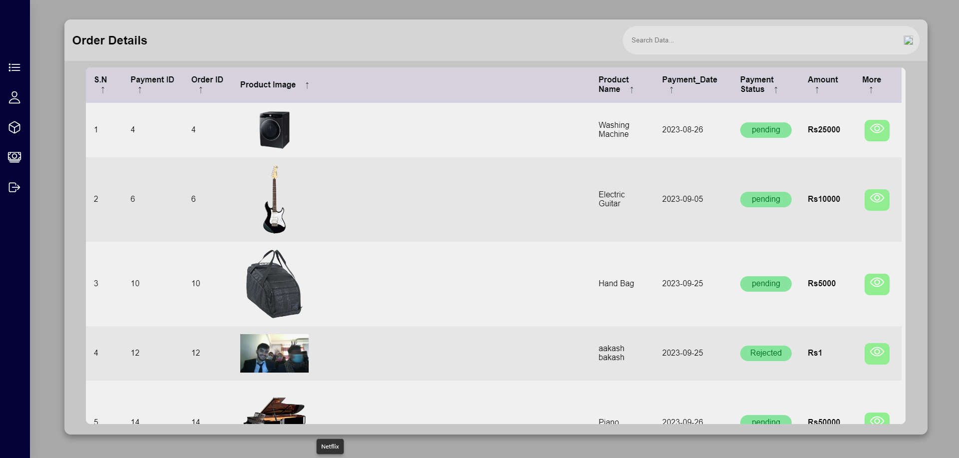

**Figure 18:Order Details**

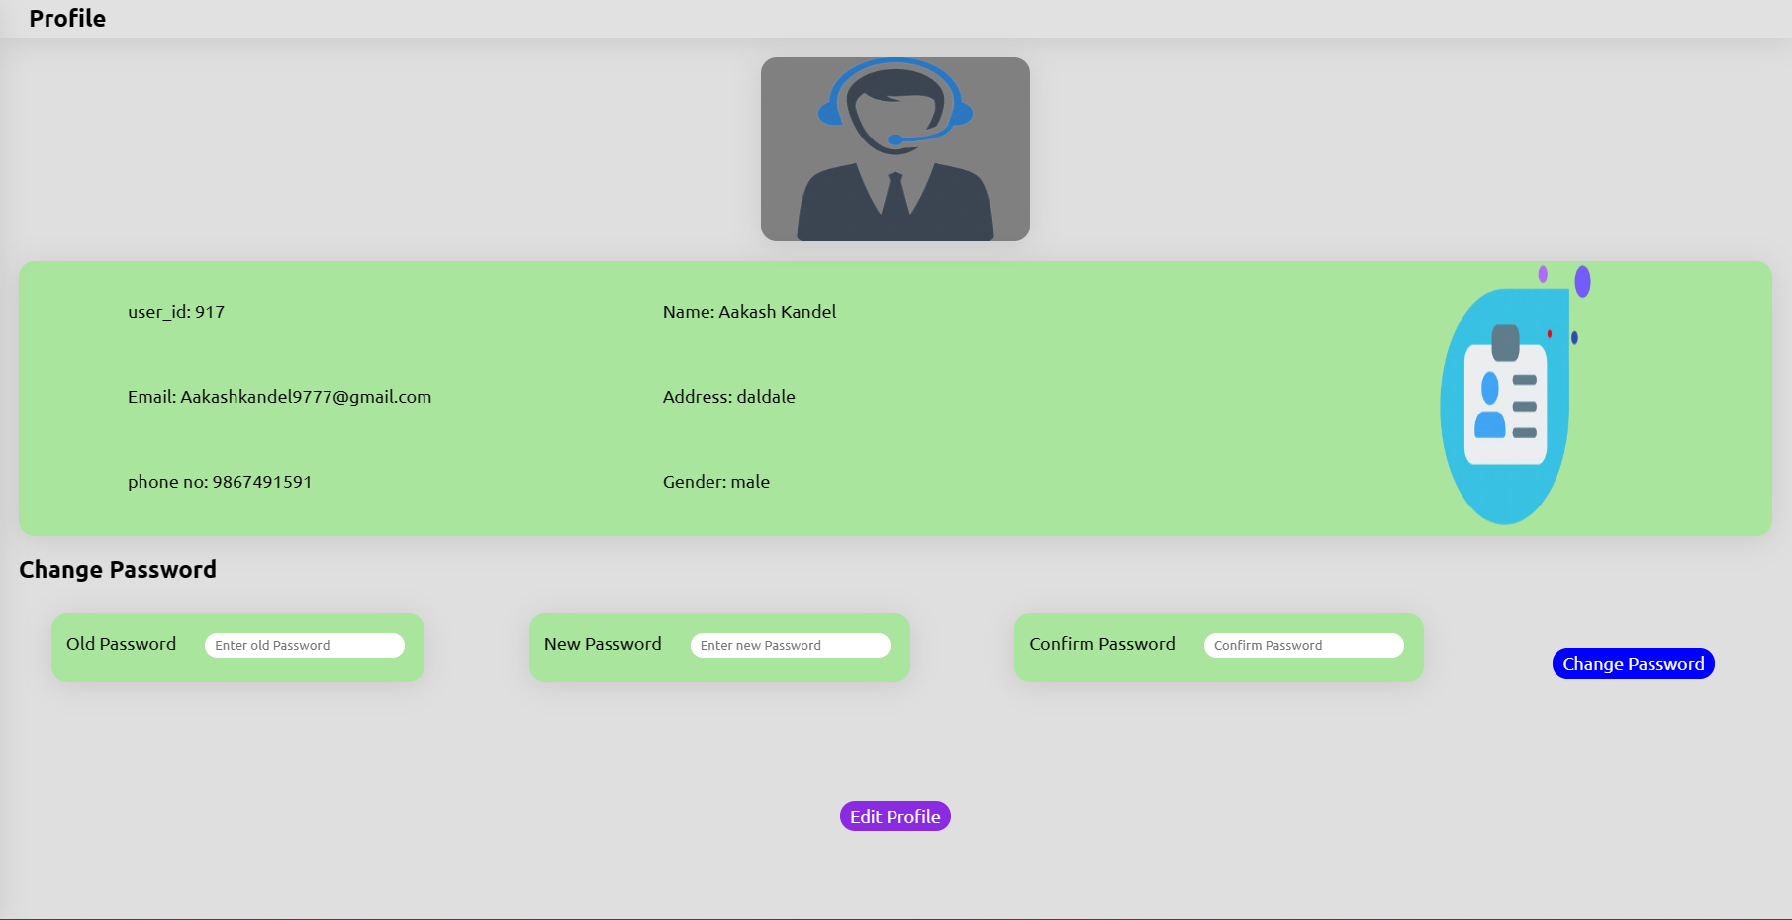

**Figure 19:Update user profile**

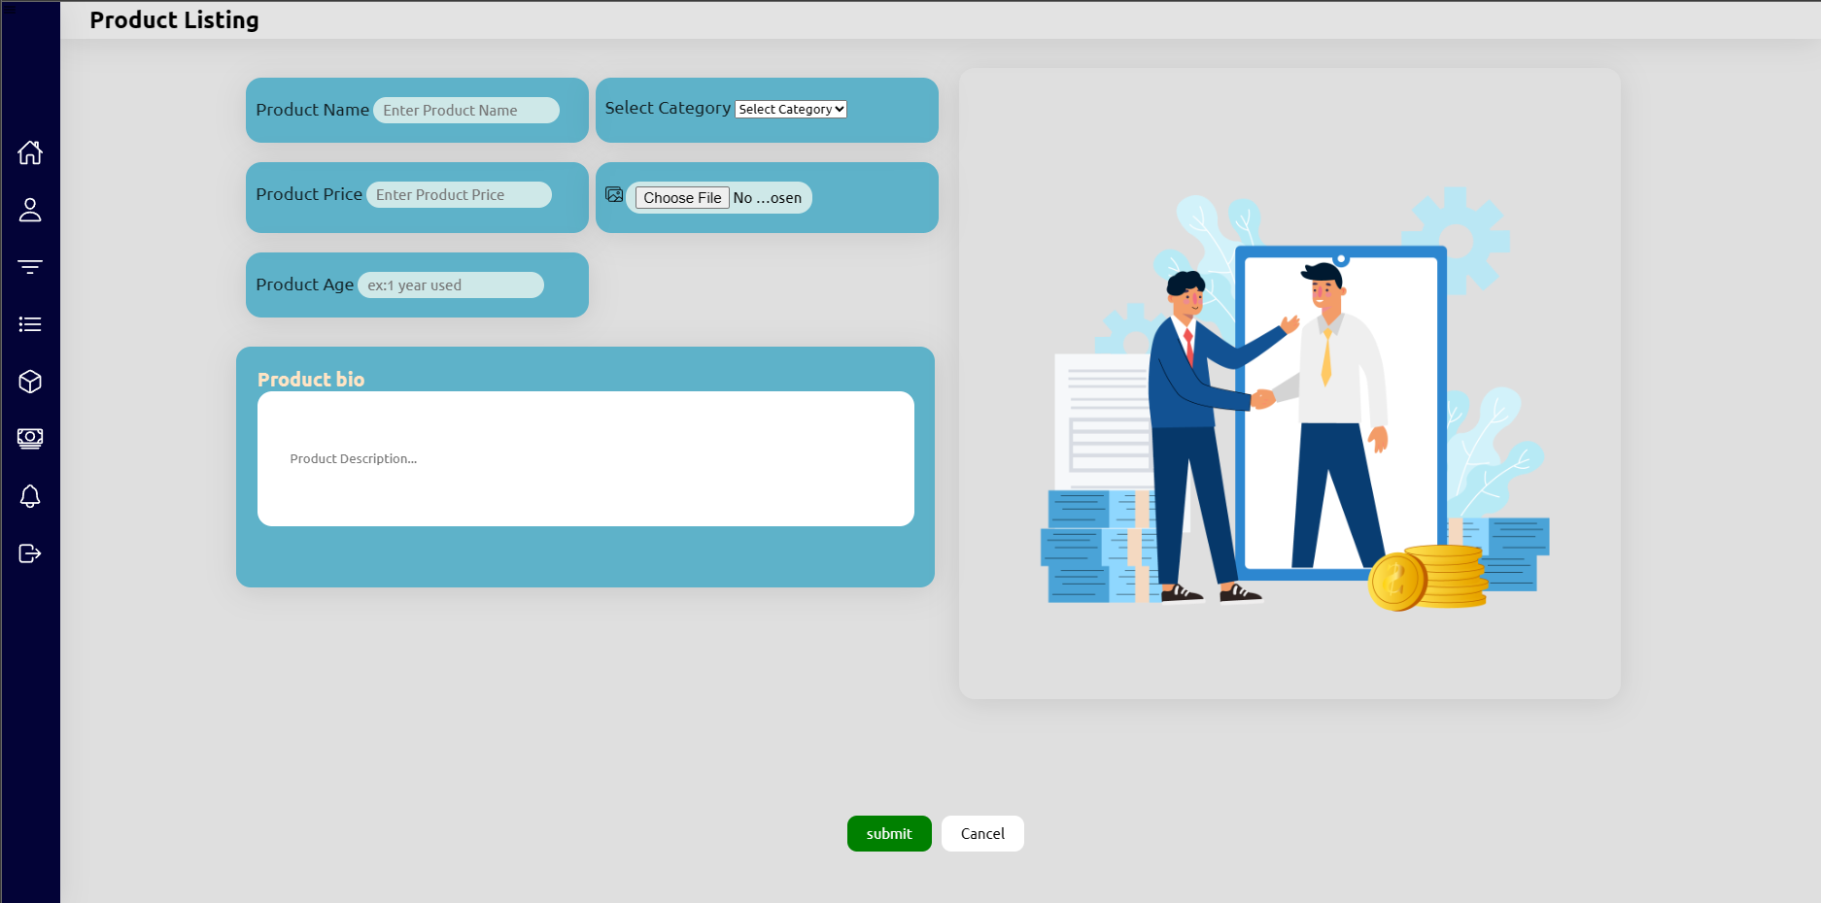

**Figure 20:Product Listing form**

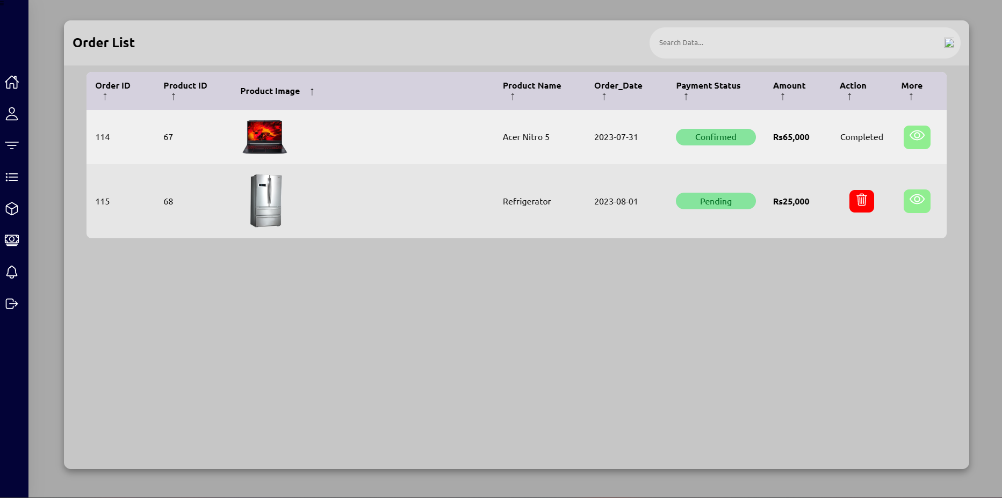

**Figure 21:Order List details**

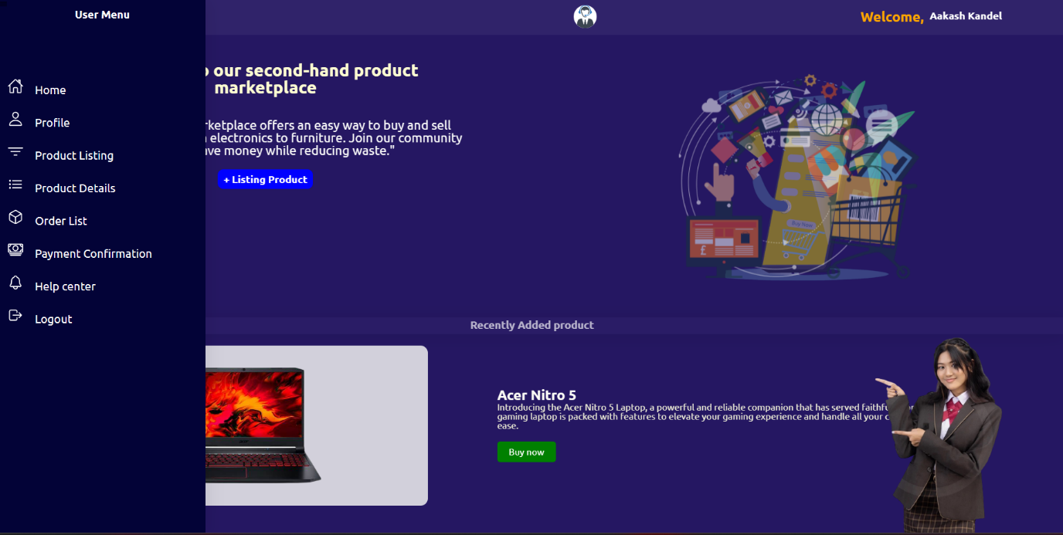

**Figure 22:User menu**

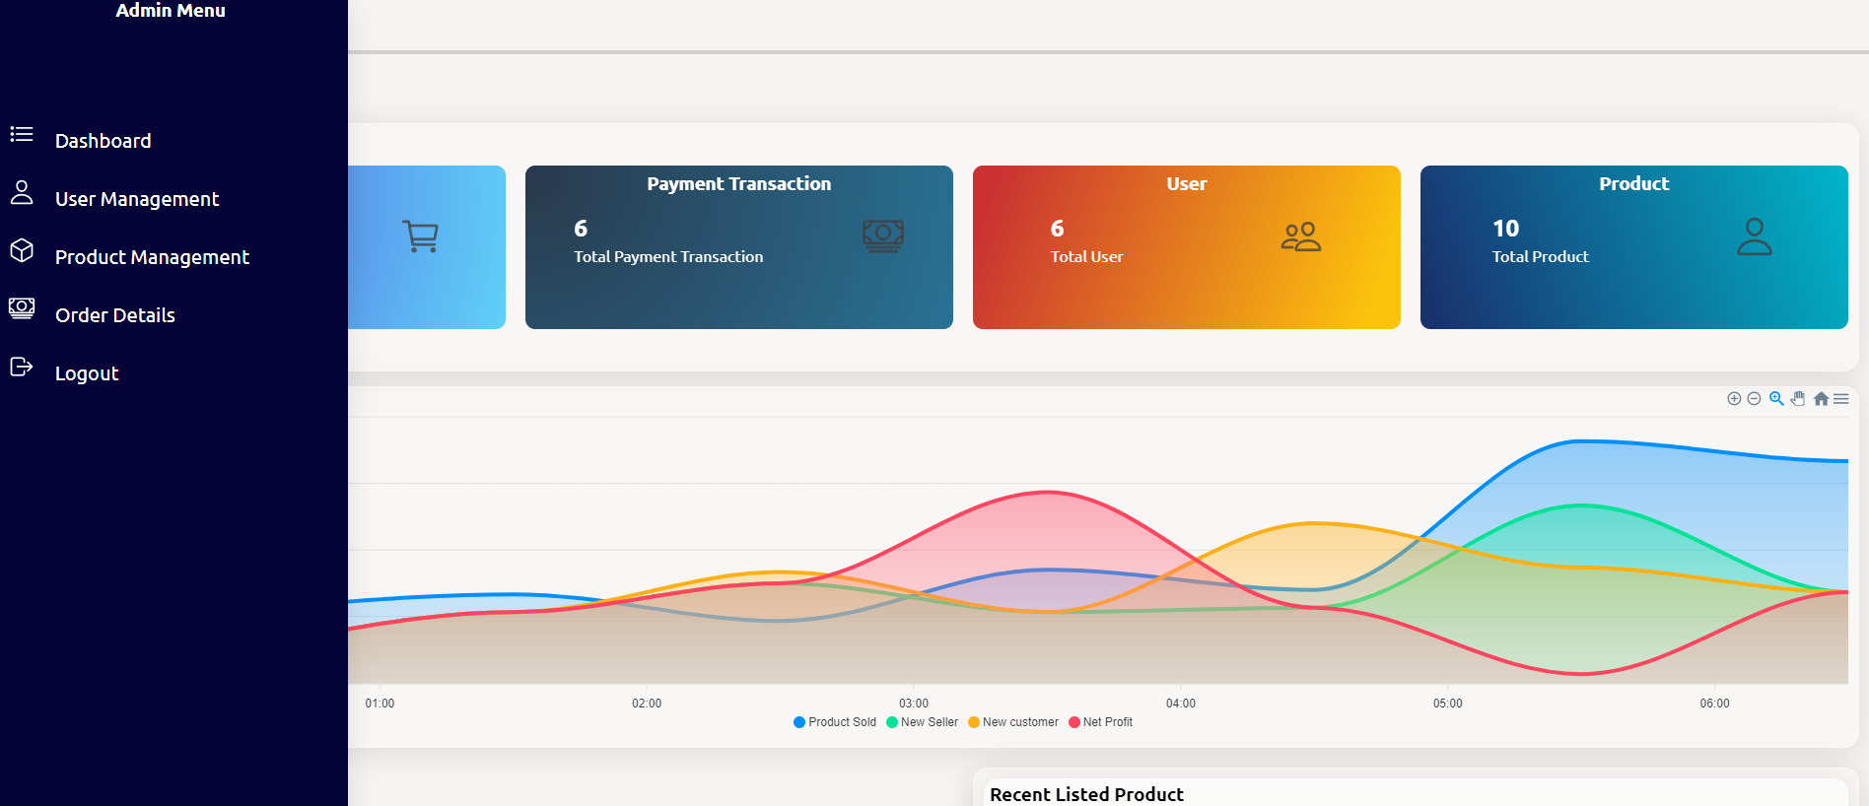

**Figure 23:Admin menu**

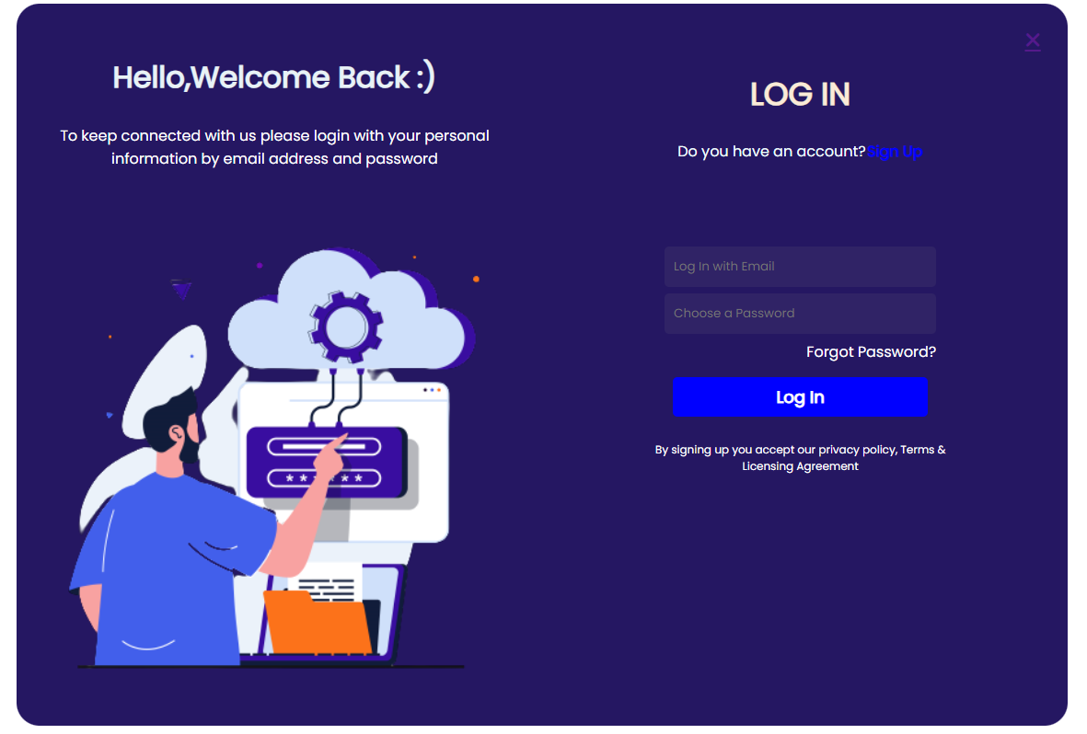

**Figure 24:Login form**

# 

**Figure 25:Signup form**

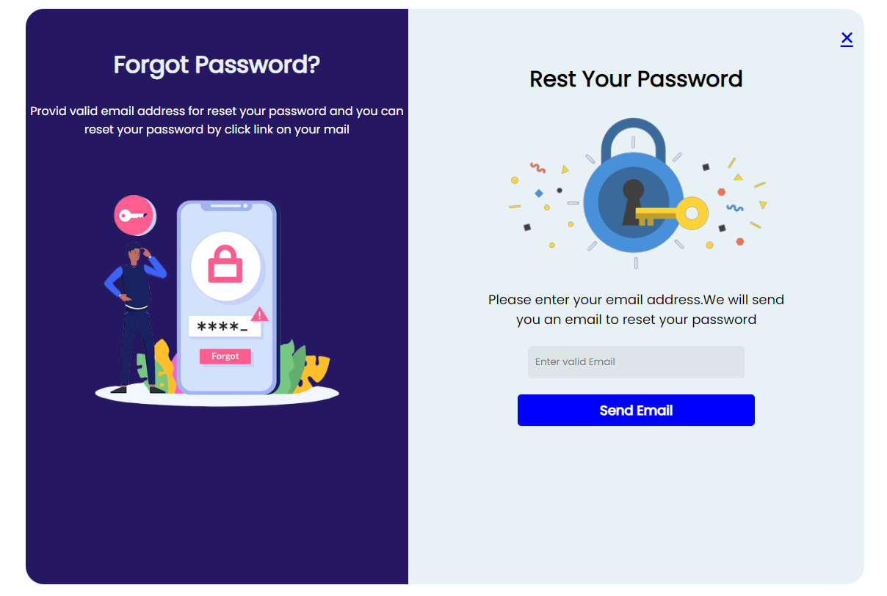

**Figure 26:Email for forgot password**

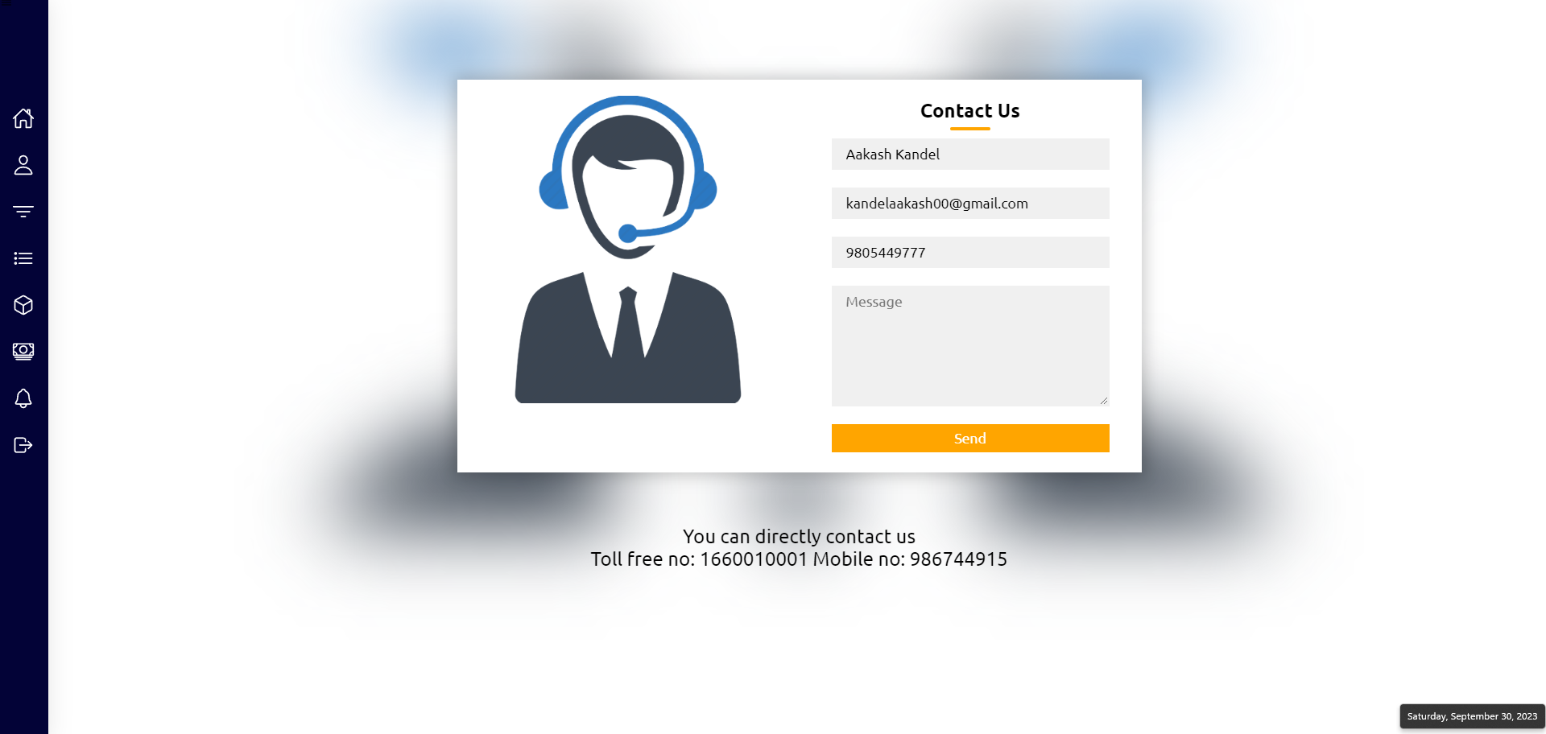

**Figure 27:User support**

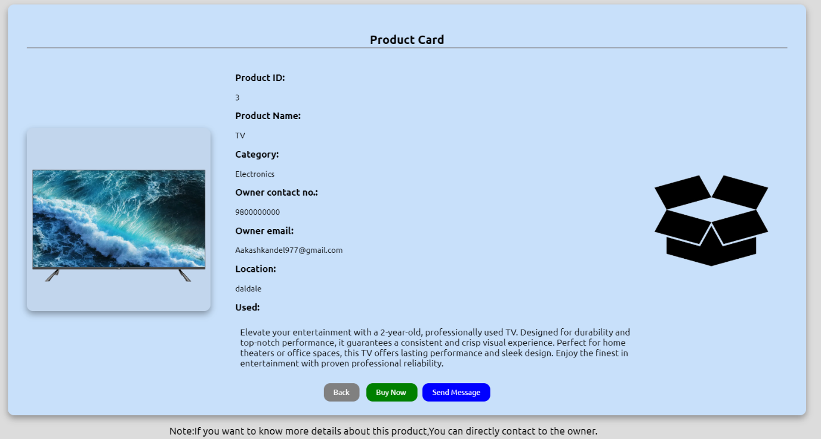

**Figure 28:Product details form**

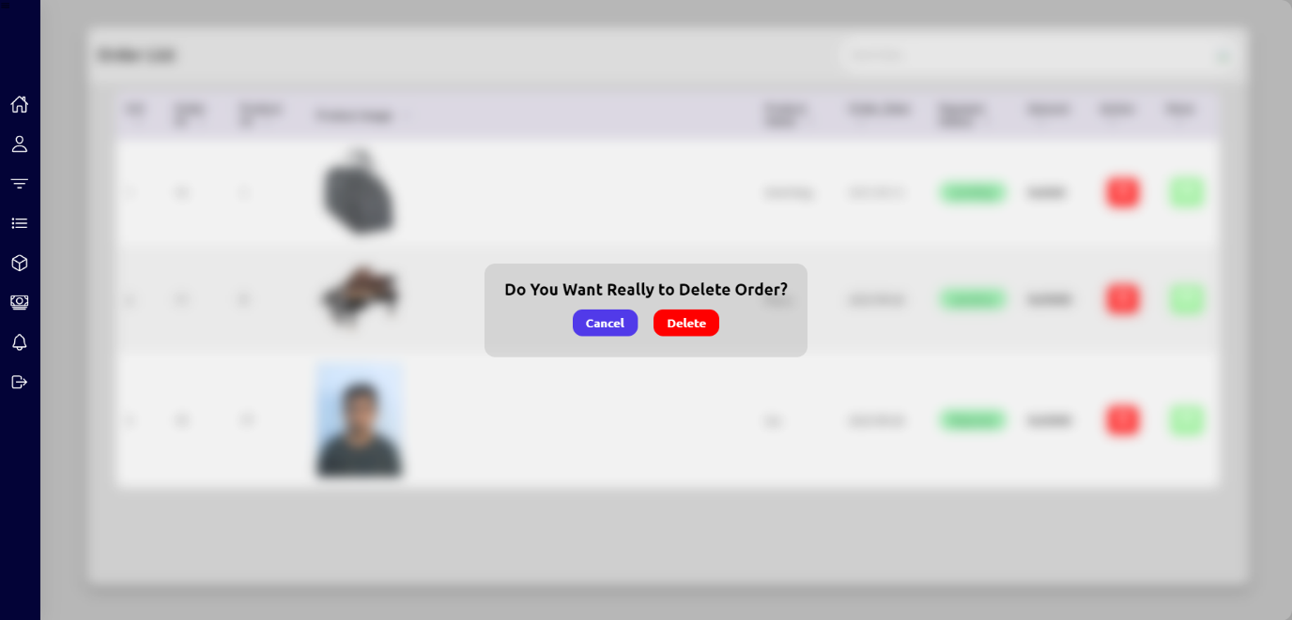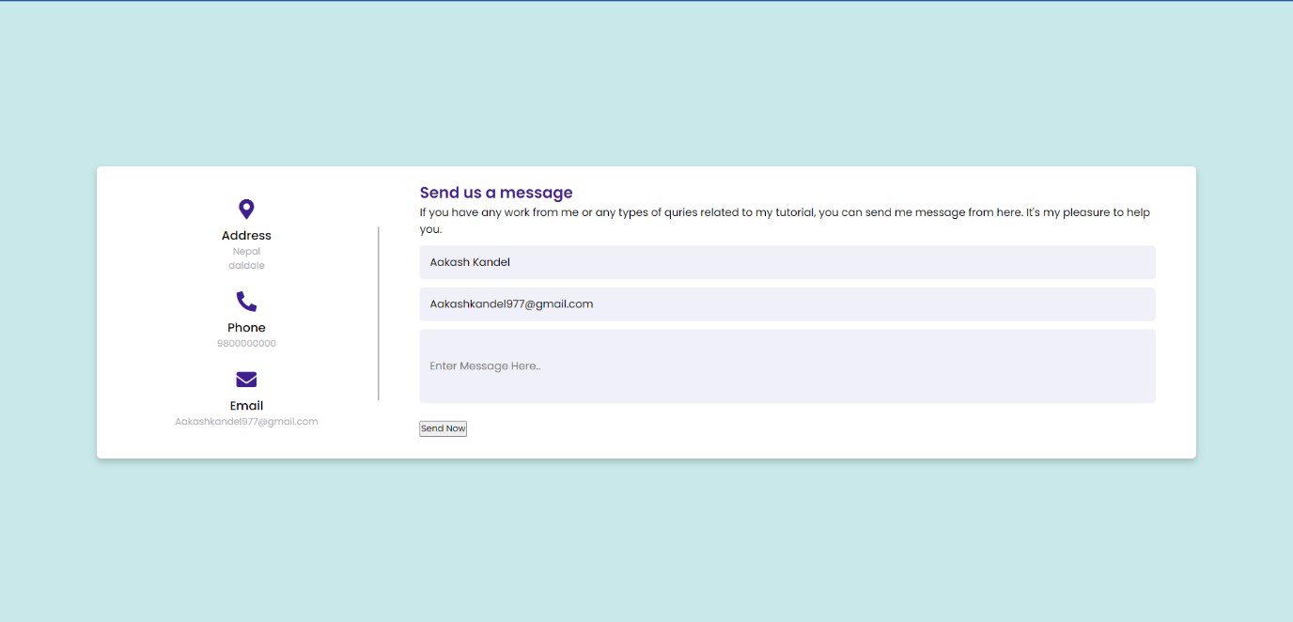

**Figure 29:Delete or Cancel interface**

**Figure 30:Send message to product owner**

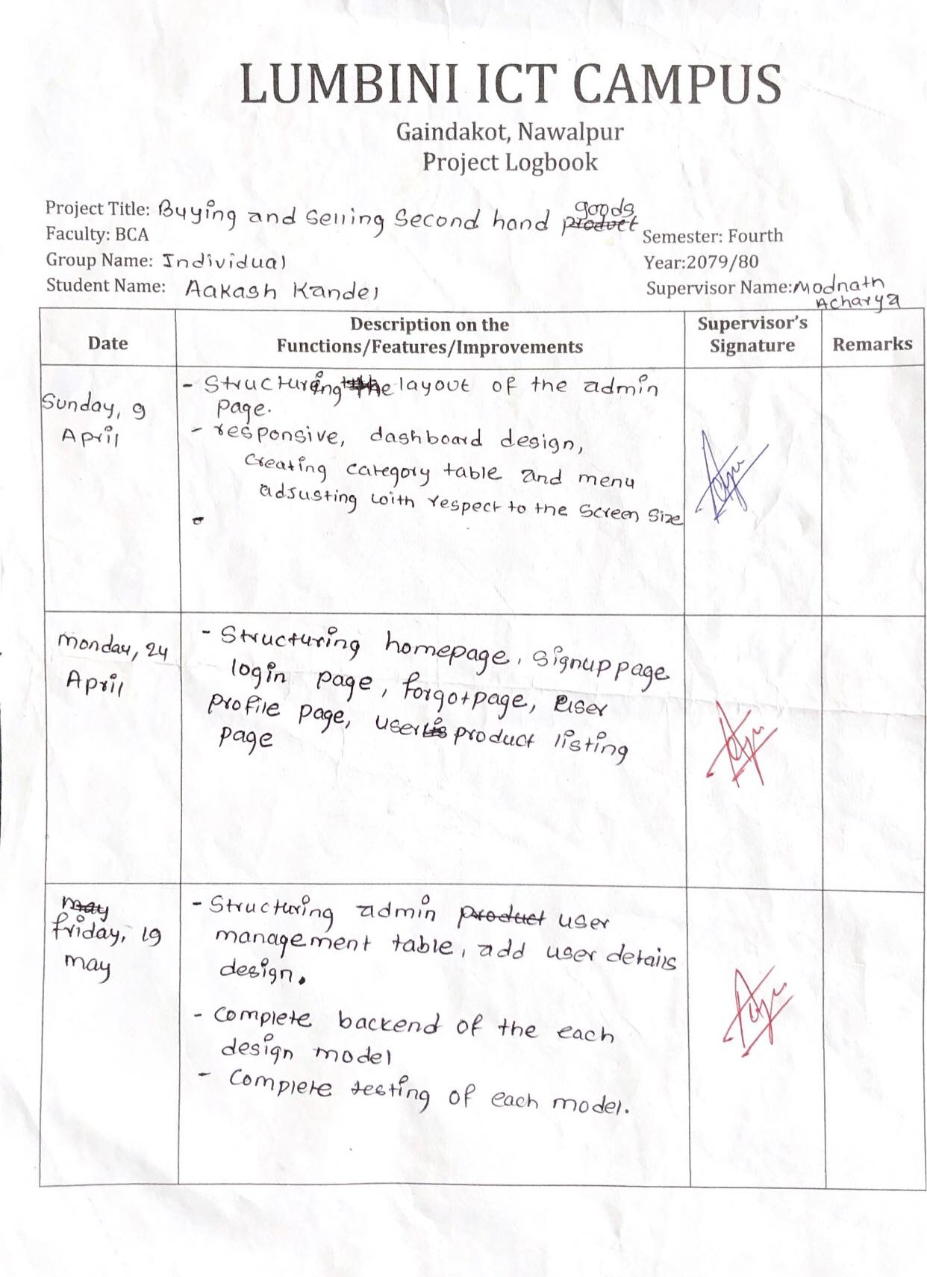

**Figure 31:Log Sheet 1**

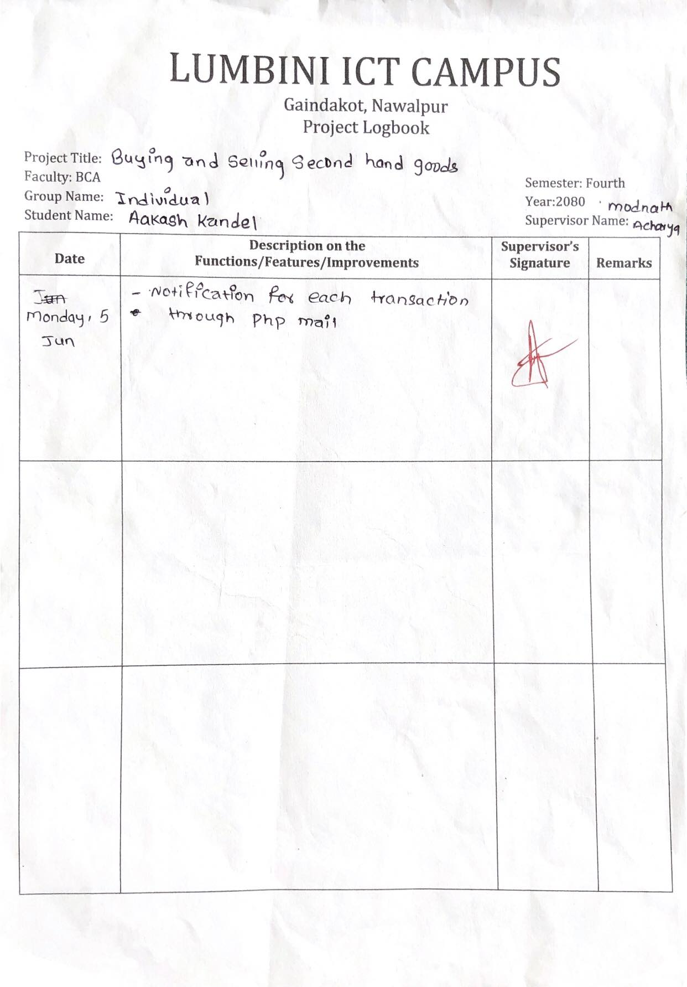

**Figure 32:Log Sheet 2**